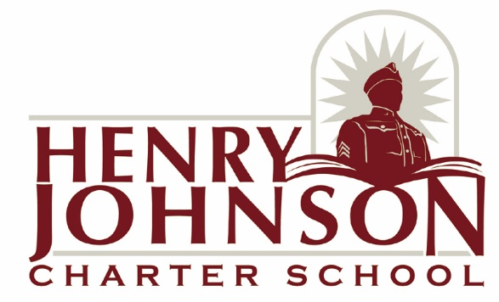
Henry Johnson Charter School Draft ARP Spending plan
 | Name | Email Address | Date of Final Review/Approval
HJCS Business Official | Jessica Hudson | jhudson@henryjohnsoncs.org
HJCS Board President | Saleem Cheeks | scheeks@gmail.com

HJCS meaningfully engaged a diverse and representative set of the applicable stakeholders in developing a Plan to use ARP-ESSER funds and implementing that Plan via several in person meetings and by posting the draft plan publicly and taking comments.
HJCS will provide public access to the Plan to use ARP-ESSER funds via the world wide web. The plan will be posted at www.henryjohnsoncs.org/resources.
Funds will be used to implement prevention and mitigation strategies that are, to the greatest extent practicable, consistent with the most recent CDC guidance on reopening school, in order to continuously and safely open and operate schools for in-person learning.
HJCS plans to use a combination of data including attendance, internally developed assessments, national norm referenced assessments, and SEL surveys to identify student needs and monitor student progress as a result of planned interventions and supports. (This relates to 5.)
HJCS will use the funds it reserves for the required minimum reserve of 20% of ARP funds to address the academic impact of lost instructional time through the implementation of evidence-based interventions, such as summer learning or summer enrichment, extended day, comprehensive after-school programs, or an extended school year. This includes the recruitment and hiring of additional staff to provide instruction.
HJCS will spend its remaining ARP-ESSER funds consistent with the allowable uses of funds to provide improved air filtration, transportation per the CDC guidelines, PPE for students and staff, SEL curriculum and training, and technology to better provide remote instruction in the event that again becomes necessary.
HJCS will ensure that the interventions it implements, including the required reserve of 20% to address the academic impact of lost instructional time, will respond to the academic, social, emotional, and mental health needs of all students, particularly those students disproportionately impacted by the COVID-19 pandemic, and including students from low-income families, students of color, English learners, children with disabilities, students experiencing homelessness, children in foster care, and migratory students.

NYSED will permit previously developed LEA re-opening plans to satisfy the ARP statutory requirement for the safe return to in-person instruction and continuity of services. LEAs must make any necessary updates to existing plans to conform with the USDE requirements within 30 days of receipt of ARP- ESSER funds and to review plan (and revise if appropriate) every six months thereafter (until September 30, 2023).

1. https://www.henryjohnsoncs.org/wp-content/uploads/2020/07/Henry-Johnson-Charter-School-Reopening-Plan-2020-2021.pdf This link points to HJCS’ most current re-opening/return to in-person learning plan and allows plans to be directly communicated to students, parents or legal guardians, school staff, and other stakeholders. The plan will also be made available in hard copy to those who request it.

2. HJCS will periodically, but no less frequently than every six months (through September 30, 2023), review and (as appropriate) revise its Return-to In-Person Instruction Plan. Consistent with section 2001(i)(2) of the ARP Act, which requires an HJCS to seek public comment on the development of its plan, HJCS must seek public input and take such input into account in determining whether to revise its plan and, if it determines revisions are necessary, on the revisions it makes to its plan, HJCS must seek public input on whether to revise its plan and on any revisions to its plan no less frequently than every six months (taking into consideration the timing of significant changes to CDC guidance on reopening schools). If HJCS revises its plan, the revised plan must address each of the aspects of safety currently recommended by the CDC or, if the CDC has updated its safety recommendations at the time HJCS is revising its plan, each of the updated safety recommendations.

HJCS will review and regularly update (at least every six months through September 30, 2023) its plan for in-person instruction at regularly scheduled meetings with a cross section of stake holders including staff, parents, and Board members, and public comments will be collected via the website.

